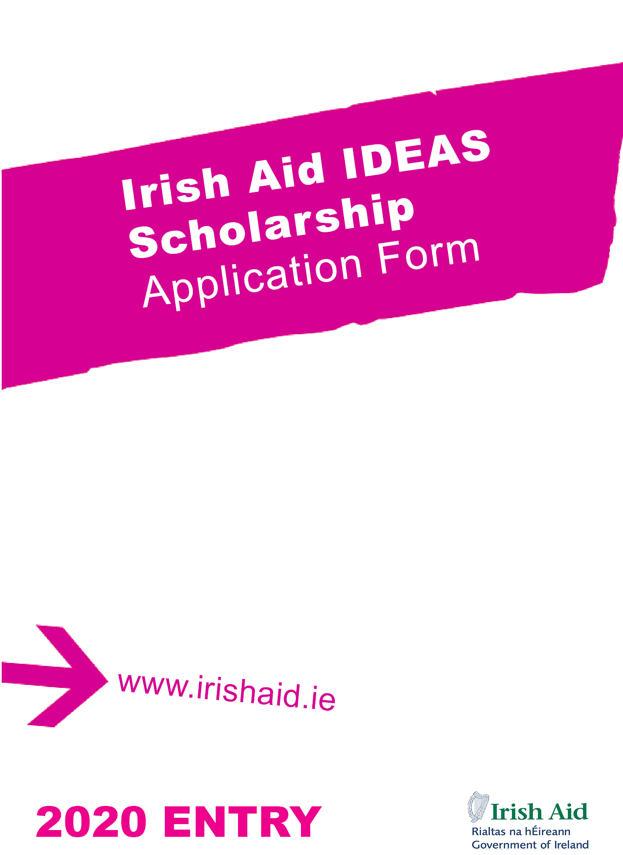
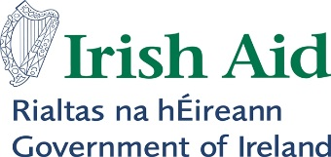

Irish Aid IDEAS Scholarship
Information Sheet

Please read the information below carefully before completing the application form

Under the Irish Development Experience Sharing Programme (known as IDEAS), full financial support is provided for one-year full-time post-graduate education for candidates from Vietnam at Irish Higher Education Institutions. The purpose of the Irish Aid IDEAS Scholarship Programme is to provide talented candidates with the opportunity to pursue advanced education and professional development in Ireland in order to contribute to the future development of Vietnam. The Irish Aid IDEAS Scholarship Programme normally covers: return airfares, full tuition, stipends to cover accommodation and subsistence costs, health insurance and other allowances, in addition to the necessary entry arrangements such as medical examination and visa.

To Apply

Summary of Eligibility Criteria

Vietnamese Citizen residing in Vietnam
Years of experience: | Minimum 2 years of full time work experience after undergraduate education.
Academic qualification: | Academic qualifications required by your chosen course.
Language proficiency: | English: IELTS: 6.5 overall (Academic); no band under 6.  IELTS results must be no more than 24 months old by 1st September 2020. TOEFL certificate is not accepted.  English language requirements can vary across courses and institutions, with some courses stipulating minimum scores in each band. Please check the specific requirements of your chosen course on the course webpage.  Please note that an IELTS certificate will still be required even in circumstances where an applicant has studied in English at undergraduate level as evidence of language proficiency may still be required when applying to courses in Ireland.
Commitment: | - Be able to demonstrate a strong commitment to the development of their home country on completion of studies.  - Be able to take up the scholarship in the academic year for which it is offered.  - Provide a letter of reference from employer.  - Meet any relevant procedural requirements of the Government of Vietnam.

Irish Aid particularly welcomes candidates from ethnic minorities, candidates living with a disability or candidates from disadvantaged groups in Vietnam.

To apply, please fill in the attached application form.

A completed application package should include the following documents listed by order:

- Your CV (maximum 2 pages).
- A certified copy of academic transcript and degree.
- Letters from two academic referees with original signatures (not e-signatures).
- A certified copy of English language certifications.
- Certified copy of your passport (identity page only) on A4 sized paper.
- One letter of reference from your employer.
- Three copies of completed application form, available at https://www.dfa.ie/irish-embassy/vietnam/ (go to News & Events), should be submitted to the following address by 11 November, 2019:

Irish Aid IDEAS Scholarship Coordinator
Embassy of Ireland
2nd floor, 41A Ly Thai To street
Hanoi, Vietnam

Failure to provide any of the above documents will render your application incomplete. Only short-listed candidates will be contacted for an interview. Interviews will be held in Hanoi and/or Ho Chi Minh City in February 2020. Scholarship award winners will be announced by July 2020. Application and supported documents will not be returned to unsuccessful candidates.

IDEAS Scholarship Programme – 2020 Application Form  Closing Date: 11 November 2019  This form is designed to be completed in Microsoft Word before being printed and signed.  Your application will be photocopied. Pages should NOT be stapled together. Please do not use spiral or other binding. Use single-sided format for all forms and accompanying documents.  Additional application information is available at www.embassyofireland.vn (go to News & Events) and at www.irishaidfellowships.ie/strands/ideas-programme | Please  attach two recent  passport-size photographs of  yourself here.  (Attach using glue  not staples or tape.  If your photos are together in a strip,  you do not need to  separate them)
SECTION ONE: PERSONAL INFORMATION
1a. Please write your full name in the order it would appear in an official document. This must match the name recorded in your passport if you have one.

Full Name:

1b. Name that you are known by (i.e. your first name or given name ):
2. Male Female

3. Date of Birth / / (Day / Month / Year)

4. Place of Birth

5. Nationality

6. Please give an email address for an account which is checked regularly. It is vital that you can be contacted by email regarding your application. If writing in an email address it should be clear and legible. If you use more than one email address you are asked to list a second email address below.

Email:

Alternate Email:

SECTION TWO: PROPOSED COURSE(S)
7. In this section, you should list the course title and academic institution for your first and second choice taught Masters courses. You are required to specify a particular course and academic institution in each case, not give a general course type.

You must select courses from the Irish Aid IDEAS Programme Directory of Eligible Postgraduate Courses available for download at https://www.dfa.ie/irish-embassy/vietnam/ (go to News & Events) and at www.irishaidfellowships.ie/strands/ideas-programme. Courses should be listed according to first and second preference and are an important consideration in the review of applications.

You should ensure that you hold the specified qualifications and academic grades required for the academic courses you intend applying for. These can be found in the Irish Aid IDEAS Programme Directory of Eligible Postgraduate Courses and on the relevant college website. It is your responsibility to ensure that your academic qualifications are of sufficient standard for your chosen course.

Please choose your courses carefully. You will not normally be permitted to revise your choices after submission, unless a programme does not run. Applicants are therefore advised to thoroughly research their course choices.

Courses must begin no earlier than July 2020.

Note: Masters degrees by research are not eligible for the programme.

First Course Choice

Name of Educational Institute:

Full title of Course:

Course Code : (if available - can be found on course website)

Course start date: / (Month/Year) Course Duration:

Second Course Choice

Name of Educational Institute:

Full title of Course:

Course Code: (if available - can be found on course website)

Course start date: / (Month/Year) Course Duration:

SECTION THREE: EDUCATION, QUALIFICATIONS AND SCHOLARSHIPS
8. You must provide a certified copy of the academic transcripts and completion certificate for each higher education qualification you have completed (see note in Section Eight regarding certified documents). Include a certified copy of the grade assessment schedule for each qualification.

Qualification | Educational Institution | Dates  From – To  (Month/Year) | Location | Final Grade Achieved

9. Please give details of any relevant professional qualifications awarded including dates, awarding body and type of award received.

10. Please give details of any educational or vocational training courses attended (other than those mentioned in Q8/9), including dates, training body and certification received, if applicable.

11. Have you previously received a higher education scholarship or award funded by any government or international organisation?

Yes No

If you answered Yes, write the name of the scholarship, the year(s) on scholarship and the name of the qualification or course undertaken.

i.

ii.

12. Have you ever previously applied for an Irish Aid Fellowship?

Yes No

If yes, please list year(s) in which you previously applied and if you were successful:

13. Have you applied, or are you intending to apply, for another scholarship at the same time as this application?

Yes No

If you answered Yes, provide the full name of the sponsor and the scholarship.

Sponsor:

Scholarship:

SECTION FOUR : EMPLOYMENT DETAILS
14. Please provide the following information in relation to your current employment:

Employing Organisation:

Address (please include city and country):

Telephone: Fax:

E-mail:

15. What type of organisation do you work for?

Local Government Community/Non-Government Organisation (NGO)
Central Government Faith-based Organisation
Other public sector organisation International NGO
Multilateral Agency Other (please state):

16. Date you started with this organisation: / / (Day/Month/Year)

Title of current post:

Type of contract (permanent/short-term):

Date you started in this post: / / (Day/Month/Year)

List in chronological order the previous positions held in this organisation and dates (please provide month and year of commencement of position):

17. Briefly describe the work of your current employer:

18. Please provide details of your current responsibilities:

19. Please provide information, on your previous employment, if applicable.

Name of Organisation | Address | Dates  From-To  (Month and Year) | Location | Position Held  Tasks and Responsibilities

SECTION FIVE: STATEMENT OF INTENT

Please complete this section paying careful attention to the suggested word count. Please note that the quality of your answers will be a key factor in how your application will be graded by the selection panel.

20. Why do you want to pursue your nominated course? How will you use the knowledge and skills acquired through your proposed course when you return to work? (approximately 400 words)

21. How will you contribute to the development of Vietnam and Ireland’s strategy in Vietnam? (approximately 200 words)

22. Why are you a good candidate for the IDEAS scholarship (approximately 200 words)

23. What are the two most significant achievements in both your professional and social activities to date? (approximately 200-300 words for each achievement)

Achievement 1:

Achievement 2:

SECTION SIX : ENGLISH LANGUAGE COMPETENCY
24. Have you completed an IELTS (International English Language Testing System) academic test?*

No Yes

I have attached the original copy/certified copy of my IELTS result to this application form.

Date of test: / / (Day/Month/Year)

Overall IELTS (academic stream) score:

Listening band: Reading band: Writing band: Speaking band:

* You will be required to demonstrate minimum IELTS English language proficiency level. This is an overall IELTS score of 6.5, with no band below 6.0. No exceptions are made.

Please note that entry to some courses may require an overall IELTS score above this requirement. Applicants should always refer to the course information for further details.

SECTION SEVEN: ACADEMIC REFEREES
28. 25. Please provide details of the two academic referees who are supporting your application. You should submit their reference letters on official letterhead with this form. They may also be contacted for further information.

Academic referees should normally be lecturers who have taught a candidate at degree or postgraduate diploma level, are familiar with their academic work at that level and are in a position to offer relevant comment regarding a candidate’s suitability for their proposed course(s).

Referee Name:

Organisation/Institute:

Address (please include city and country):

Telephone Number: Fax Number:

Email Address:

Referee Name:

Organisation/Institute:

Address (please include city and country):

Telephone Number: Fax Number:

Email Address:

SECTION EIGHT: SUPPLEMENTARY INFORMATION
25a. Do you have a passport? Yes No (Go to Q26)

b. Country issuing passport:

c. Date of expiry : / / * (Day/Month/Year)

* For study in Ireland, your passport should be valid for the duration of your study period.

d. If you hold a passport for another country or a diplomatic passport, please give details:

26. Have you ever been convicted of a criminal offence? Yes No

If the answer is Yes, please provide details of the offence for which you were convicted, including the nature of the offence and the sentence received.

27. Please provide (a) a home mailing address (not a PO Box) where registered post can be delivered and signed for, and (b) a PO Box address if you have one.

a) Home Address (please include city and country):

b) PO Box Address, if applicable (please include city and country). Please indicate if you wish to use this address as your primary mailing address for correspondence purposes by ticking the box:

c) Contact phone numbers: (Please give at least two numbers if possible, e.g. work, mobile, landline)

Your main telephone number:

Other telephone number (1):

Other telephone number (2):

28. Name someone who can be contacted in an emergency.

Name:
Relationship to you (e.g. spouse, father, mother, sibling):
Home Address (please include city and country):

What telephone numbers can be used to contact them? (Please give at least two numbers if possible)

Main telephone number:

Other telephone number:

Does this person speak English? Yes No

Clearly write an email address for an account which they check regularly.

Email:

SECTION NINE: DOCUMENTATION CHECKLIST
All relevant documents listed below must be included with your application, in the sequence shown.

Supporting documents must be certified true copies of original documents with the official stamp and signature of a justice of the peace, solicitor, notary public, an official from an embassy of Ireland, or another authorised official. Photocopies of certified documents are not acceptable but a certified photocopy of a document with an original certification is acceptable. The submitted documents must bear the official stamp and signature of the certifying authority. Certificate must be stamped and signed on the front of the document – all documents submitted must be single-sided. It is recommended that you obtain a minimum of three certified copies of all of your documents as you will need to provide certified copies for your course applications, as well as retain a copy for yourself. Where original documents are not in English, you must provide certified true copies of official English translations. Documents should be single-sided and not stapled, bound or laminated.

You should mark each box below with ‘X’ to indicate that the document is present. If you do not possess a particular document (e.g. birth certificate) you should explain in the notes section below.

You are advised to make electronic scans of all documents submitted with your application.

Essential
A current (dated) curriculum vitae - a brief history of your education, work experiences and skills, including exact dates e.g. month/year in which you started and completed your studies, work experiences. Maximum 2 pages.
A certified copy of the completion or graduation certificate for each higher education qualification that you have completed (in English).
A certified copy of the academic transcript for all higher education qualifications and the grading schedule for each qualification (in English).
Letters from your two academic referees with original signatures (Q25). E-signatures are not accepted.
A certified copy of the identity page of your passport (on A4 sized paper).
A reference letter from your employer on official letterhead, supporting your Irish Aid IDEAS scholarship application for your proposed course of study. If you are not currently working, please provide a reference letter from a past employer, or another similar reference letter.
An original or certified IELTS academic English test certificate. Photocopies will not be accepted. Test results must be no more than 24 months old by the commencement of study.

If applicable:
A certified copy of your Vietnamese ID (in English) on A4 sized page, only applicable where no passport is provided.
A certified copy of official evidence of any name change (in English).

Do not include copies of certificates from short courses or for non-degree level programmes.
NOTES ON DOCUMENTATION:

SECTION TEN: DECLARATION
I am in good health and if accepted for the Irish Aid IDEAS Scholarship Programme will undertake the necessary medical examinations and provide the required medical certificates.

I give my permission for information and documents submitted as part of my application to be shared with:
- the managing agency for the IDEAS Scholarship Programme;
- the consultant for Irish Aid’s scholarship selection process; and
- appropriate staff of my nominated Higher Education Institutions, as required, regarding any course applications and place offers;
- any other individuals, companies and/or organisations as necessary to make arrangements related to my participation in the Scholarship Programme.
When your application form is received, we create a record in your name, which contains much of the personal information you have supplied. This personal record is used solely in processing your candidature. Such information held is subject to the rights and obligations set out in the Data Protection Acts, 1988, 2003 and 2018.

I understand the purpose for which Irish Aid scholarships are awarded and the necessity to abide by the conditions specified.

I certify that all the information I have given is true, complete and accurate to the best of my knowledge.

Signature: Date: / / (Day/Month/Year)

